Technical guide
Dribdat 2.0
Module 646-2
Projects

Students : Jonathan Schnyder, Caroline Moreira,
Anthony Ritz, Daniela Lourenço,
Mickaël Coluccia

Teacher : Cotting Alexandre

Product Owner : Oleg Lavrovsky

29th April 2019

Contents
Introduction 3
Source Code 3
Technologies used 3
Frontend 3
Backend 4
Unit test 4
Project 6
Vue.js 6
Vuex 8
State 9
Mutations 10
Actions 10
Getters 11
API 11
Développer guide 13
Backend 13
Frontend 14
Unit Test 14
Possible issues 18

Introduction
As part of the 646-2 Projects course, we developed a hackathon web site in vuejs and used the SCRUM methodology.
A version of this website already exists (dribdat 1), we had to be inspired to try to make an improved version (dribdat 2) completed and more simplified.
The goal of this technical guide is to provide useful information for further developers in case of the client would re-use what the team has done.

Source Code
Our application’s source code can be found here : https://github.com/hackathons-ftw/dribdat2_frontend
We are using the dribdat application’s API and modified a little the main route for retrieving data. It can be found here : https://github.com/hackathons-ftw/dribdat2

Technologies used

Frontend



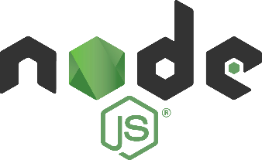



Vue.JS: Vue is a progressive framework for building user interfaces. The core library is focused on the view layer only and is easy to pick up and integrate with other libraries or existing projects.
Vue CLI: It was used to work the command line project
Module VueX : VueX is used to have a state management pattern and a library for Vue.js applications.
Module Axios : The module AXIOS is used to retrieve API data.
Node.js : it's used to retrieve all the changes in a development environment
DISQUS : It is a comment plug-in, we used it to be able to leave a feedback
GitHub : GitHub is used to recover activities and issues of the repository.
Bootstrap : Bootsrap is used to do the design

Backend
The backend was taken from the previous version of Dribdat (dribdat 1). We made only some changes and added roots.
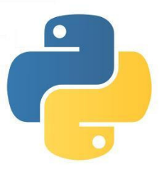


Python: The version of python we used for this project is the version "python2.7" which is compatible with flack.
Flask: Use python 2.7 to generate a virtual environment

Unit test
JEST : To do the unit test with continuous integration of Travis.




Project

Vue.js
The project was organized according to the recommendation vue.JS. We separate the different screens in a specific folder and each folder contains all the components for this screen. And then each component is added in the correspondent Vue.
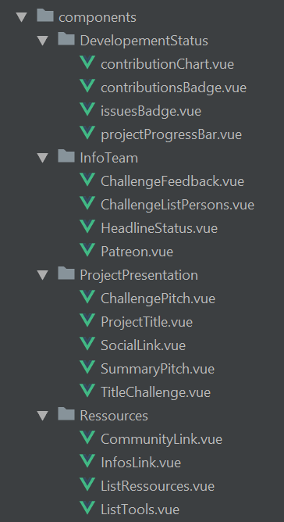
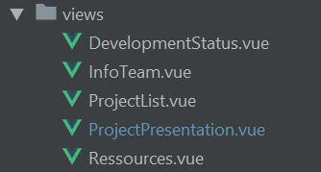

Vue file are split in 3 parts:
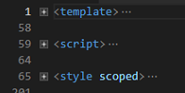
In the <template> tag you’ll write your html code specific to your component. You can also call component that you have created. (e.g. <navigation>)
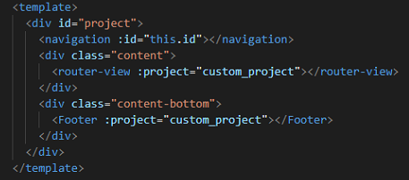
In the <script> tab you’ll write your javascript code to set variables, add methods, get props from the component, etc...
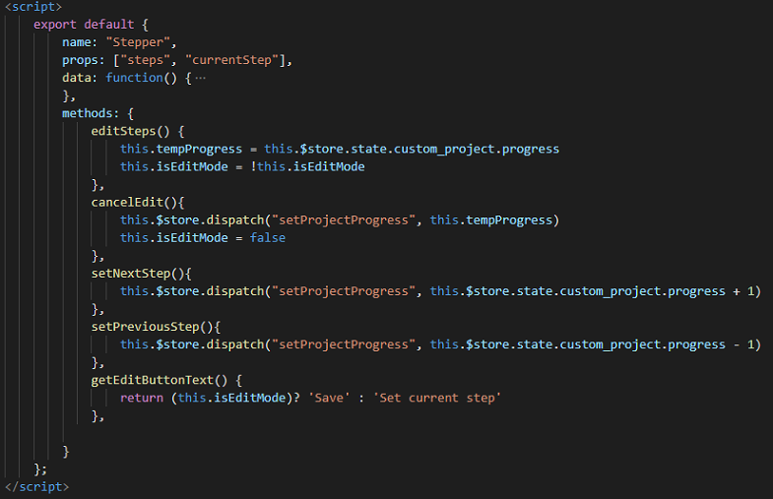

In the <style> tag you’ll write your CSS code. You can “scoped” your style to this component to avoid modifying other components with your specific style.
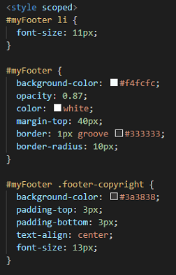

Vuex
According to the official documentation, Vuex is a state management pattern + library for Vue.js applications. It serves as a centralized store for all the components in an application, with rules ensuring that the state can only be mutated in a predictable fashion. It also integrates with Vue's official devtools extension to provide advanced features such as zero-config time-travel debugging and state snapshot export / import.
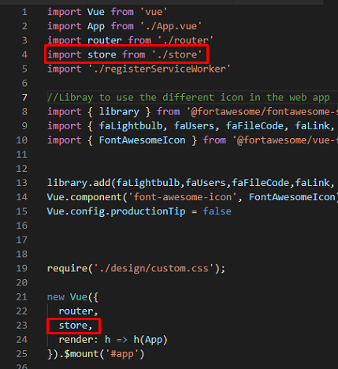
In the main.js file we import the store that implements Vuex:

In the store.js file we export a new Vuex.Store with some parameters:
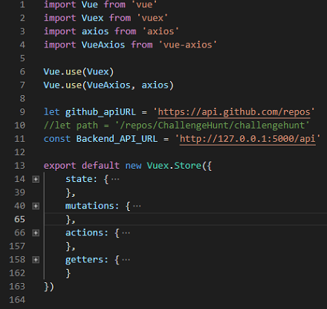

State
We create some variable that we’ll use later in our program and that we want to keep changes without save it on database. Custom_project is a copy of the project loaded from the API and will be used inside the application to avoid errors by modifying the other project. We set also this variable for the “edit” part (that has been comment in the code after discussion with the product owner).
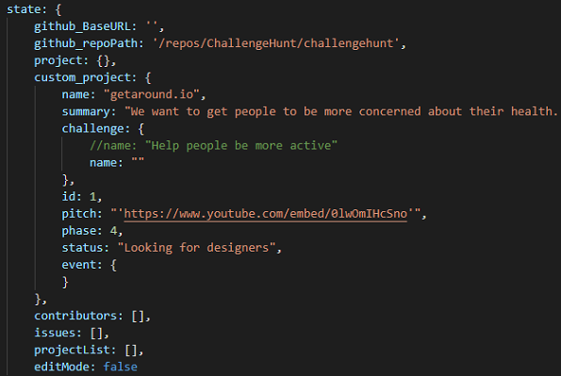

Mutations
Mutations allows you to modify stored variables by calling these methods.
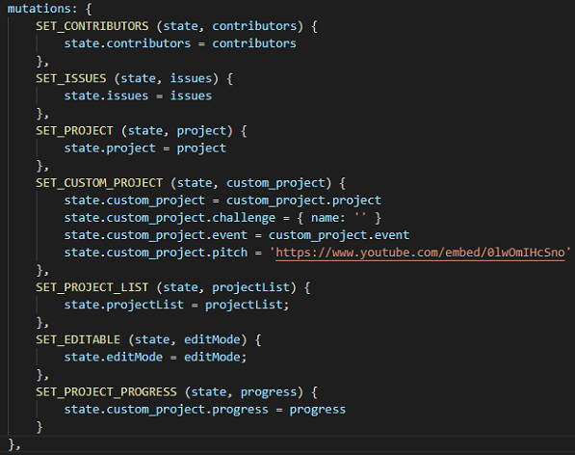

Actions
Mutations allows you to modify stored variables by calling these methods from your Vue or Js files.
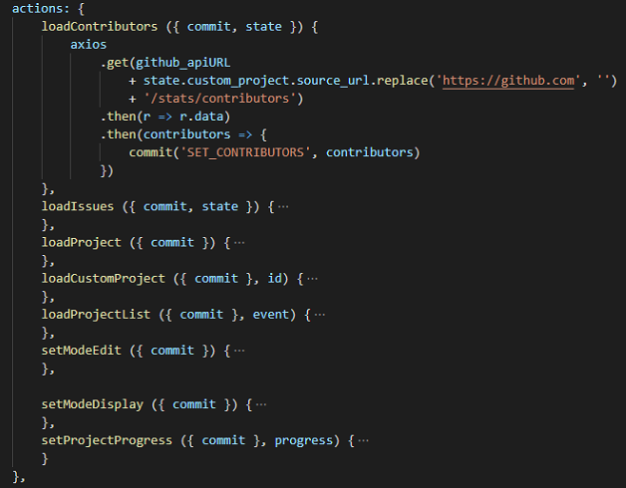

Getters
Getters allows you to get data from the store.
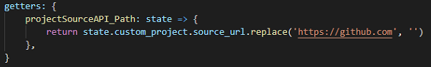

API
There are several API calls that admins can use to easily get to the data in Dribdat in CSV or JSON format. See GitHub issues for development status.
Basic data on an event :
- /api/event/<EVENT ID>/info.json
- /api/event/current/info.json
Retrieve data on all projects from an event:
- /api/event/<EVENT ID>/projects.csv
- /api/event/<EVENT ID>/projects.json
- /api/event/current/projects.json
Recent activity in projects (all or specific):
- /api/project/activity.json
- /api/<PROJECT ID>/activity.json
Search project contents:
- /api/project/search.json?q=<text_query>
Push data into projects (WIP):
- /api/project/push.json
We only use the /api/project/{id}/info.json route to gather all the relevant data for a project. the data is structured like this :
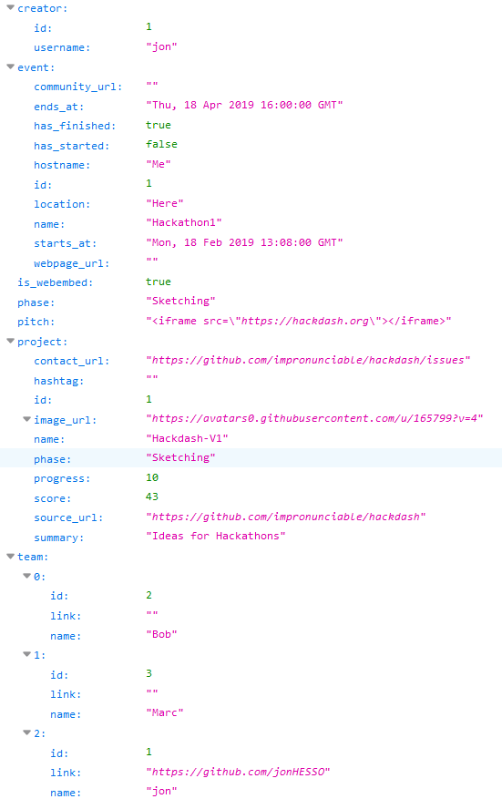
This data should be pretty self-explanatory. However some parts still need a little explanation:
- is_webembed : boolean indicating if the project pitch should be embed into the project presentation page.
- pitch : url of the pitch to display
- project.score : completion of page, calculated by the backend
- source_url : url to the source code repository

Développer guide

Backend
Install Python, Virtualenv and Pip or Pipenv to start working with the code. You may need to install additional libraries (libffi) for the misaka package, which depends on CFFI, e.g. sudo dnf install libffi-devel.
Run the following commands from the repository root folder to bootstrap your environment using Pipenv:
pipenv --three
pipenv shell
pipenv install
Or using plain pip:
pip install -r requirements/dev.txt
By default in a dev environment, a SQLite database will be created in the root folder (dev.db). You can also install and configure your choice of DBMS supported by SQLAlchemy.
Run the following to create your app's database tables and perform the initial migration:
python manage.py db init
python manage.py db migrate
python manage.py db upgrade
Finally, run this command to start the server:
FLASK_DEBUG=1 python manage.py run
You will see a pretty welcome screen at http://localhost:5000

Frontend
Node.js, git and npm must be installed in your environment to be able to launch the frontend.
Firstly, clone our repository:
git clone https://github.com/hackathons-ftw/dribdat2_frontend.git
Then, run the following command to install all the missing dependencies:
npm install
Finally, launch the node server:
npm run serve
Frontend should be running at http://localhost:8080

Unit Test
All the tests are in the "unit" folder and are written with: .spec.js.
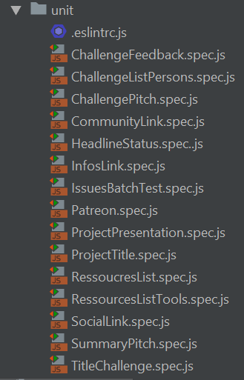
We use JEST to create, execute and test the components. The tests are done in order to check if the component is displayed correctly or if the behavior of the component is correct. The tests are executed automatically with each commit using the continuous integration of Travis.
Example of Build History:
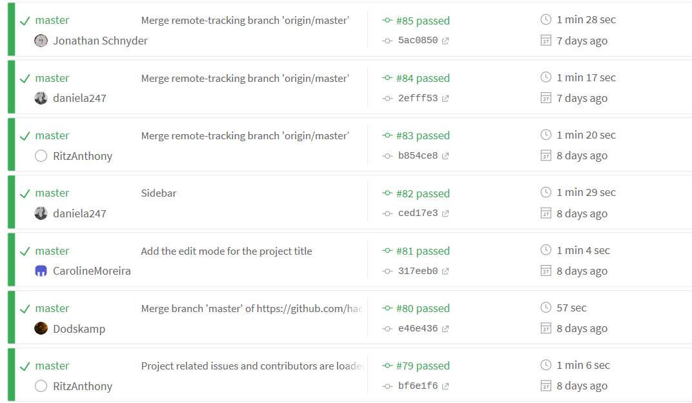

Result on Travis when a test is passed:
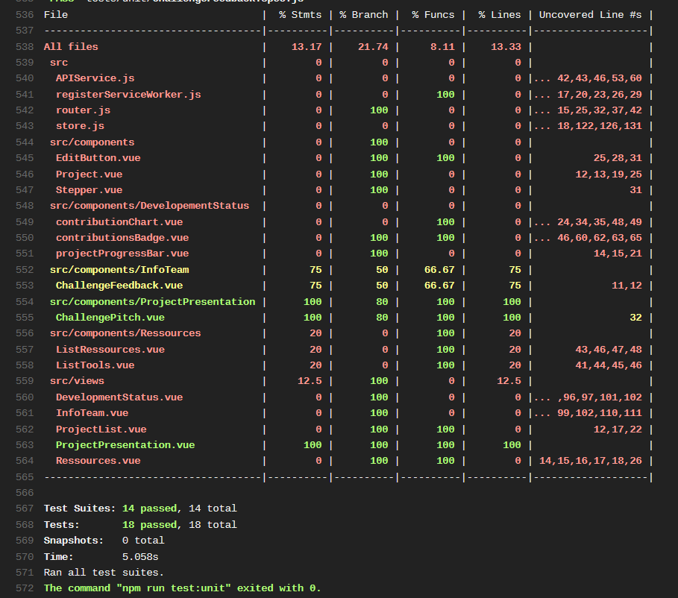

Result on Travis when a result is not passed:
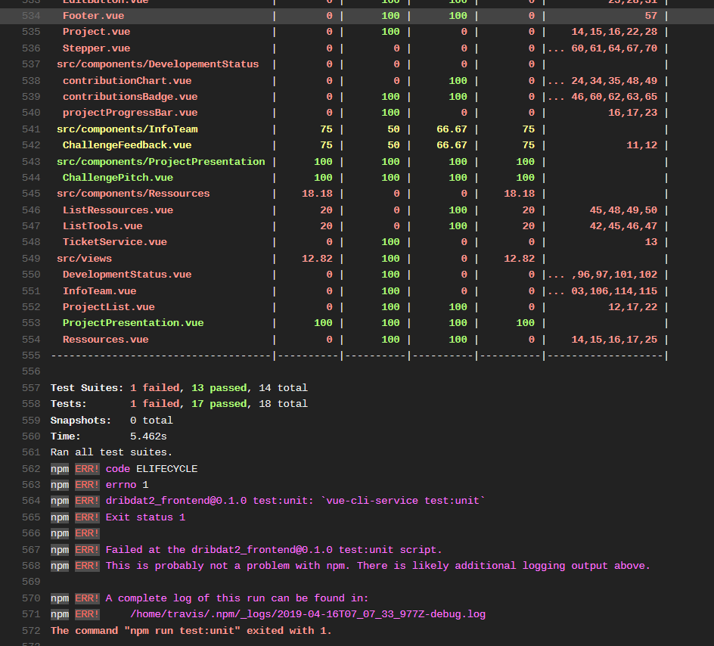

Possible issues
If you get these errors:
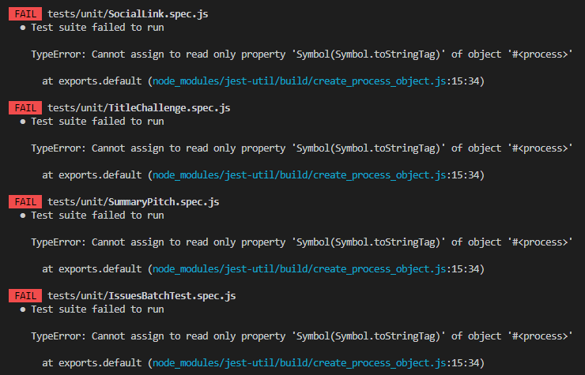
You must change your version of node by using this command line:
Windows:
npm install -g nvmw
nvmw use 11.10.1
Linux:
npm install -g nvm
nvm use 11.10.1

